What I Will Learn Art II/III, Sculpture I & 2?

Lip or Rim

Neck

Handle

Shoulder
As an artist, I can identify the various stages of the ceramic process.
Plastic ● Greenware ● Leatherhard ● Bone dry
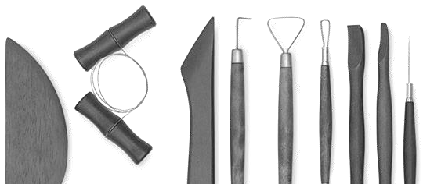
Bisque ● Glazeware

As an artist, I can integrate the characteristics of the tools of a selected media in original artworks to support artistic purposes.

Wire cutter Modeling tools

Body or
Walls

Foot or Base

Parts of a Pot

Rib
Wire, Loop & Ribbon tools

Wooden knife
Needle tool

Image: dickblick.com

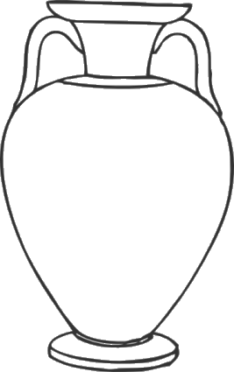
As an artist, I can apply my understanding of the health and safety issues related to creating with clay.

As an artist, I can utilize various ceramic decorating techniques and materials to support artistic purposes.

Underglazing ● Glazing ● Sgrafitto
Surface decorating (sponging, spattering, masking)
As an artist, I can utilize various clay building methods and techniques to manipulate form, texture and convey meaning in my work.

Pinch and pull ● Coil ● Slip and Score ● Slab Throw (pottery wheel) ● Drape or press mold Extrude ● Slip cast ● Pull a handle

Principles of Design:
- Balance
- Contrast
- Repetition
- Movement
- Rhythm
- Pattern
- Emphasis
- Harmony
- Unit
- Proportion

Ceramic vocabulary:
As an artist, I can discover the work of ceramics artists

elasticity
shrinkage texture grog wedging
recycled clay
kneading vitreous molds aesthetics critique
sgrafitto
drape extruding centering coning trimming glaze underglaze raku armature
sculptural
slip functional
non-functional calipers
flange stoneware earthenware terracotta porcelain
both past and contemporary.

Examples may include: Ancient Greek Potters Jomon Ware Pottery Maria Martinez
Beate Kuhn Shiho Kanzaki Peter Voulkos Beatrice Wood Victor Spinski Benard Leach

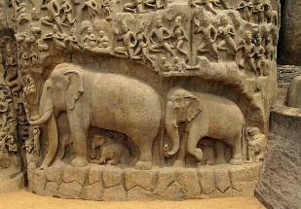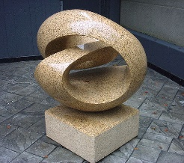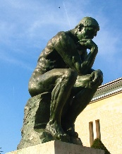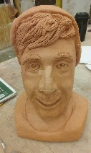
Sculpture can be creating through:
- Carving
- Modeling
- Casting
- Construction
- Assembling
- Armature
- Found Objects
- Construction
Additive
Subtractive
In the Round
Relief

Materials used for Sculpture:
Wood, Stone, Plaster, Metal, Foam, Clay, Glass, Paper, Plastic, Wire
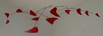
Kinetic/Mobile

Jewelry:
- Fabrication
- Soldering
- Sawing
- Piercing
- Inlay
- Overlay
- Links
- Lost Wax
- Casting
- Investment
- Molds
- Rivets
- Chain Making
- Joining
- Polishing
- Bending
- Forging
- Cold Connections
- Patina
- Engraving
Forms of Jewelry:
- Bracelets
- Rings
- Necklaces
- Pins
- Broache
- Earrings
- Metalsmithing

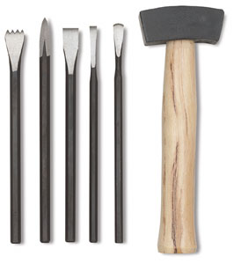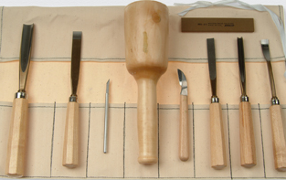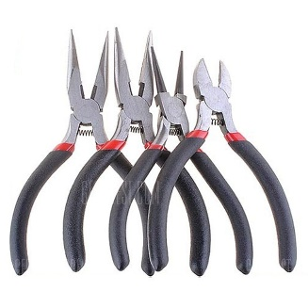
Artists to Study:
- Henry Moore
- Maria Alquilar
- Aguste Rodin
- Michelangelo
- Helenistic Greek sculpture
- St. Peters
- Lung Men
- Maya Carvings
- David Hostetler
- Enzo Torcoletti
- Duane Paxson
- Janice Kluge
- Sandy Skoglund
- Herb Parker
- Jesus Moroles
